1. Git branch
2. yamini@DESKTOP-TAGRVN1 MINGW64 /c/users/yamini/Desktop/DevOps/awspractice/kubek8s (new-one)
3. $ git branch
4. master
5. \* new-one
6. new-two

2. git checkout –b new-one ( it creates and checks out branch)

3. git branch to see the branch

Git remote (to see the origin)

Origin is by default the remote layer which is not local and pushes to remote server.

4. to see the status : git status

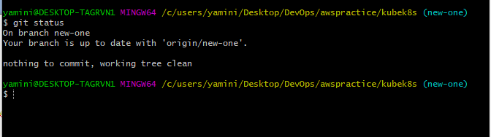

Git status also shows whether your branch is up to date or not

Issue: When a developer/ Team says your branch is not pushed we can check our status using git status and then push the branch instead of commit.

5. to see the latest commit which is head state of that branch: git show HEAD

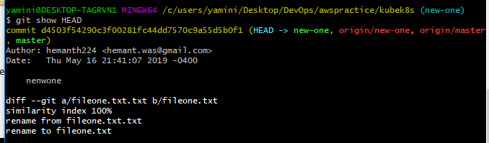

1. To see the history of commits : git log --we can see d4503f is the latest commit

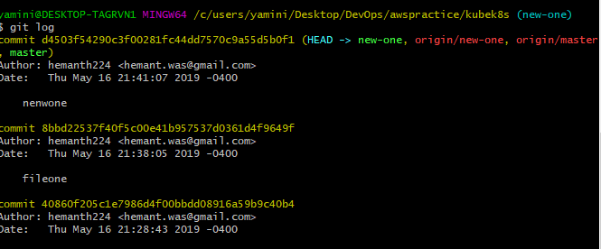

1. Difference between branches: using git diff branch1 branch2

(always git diff with branch-branch or tag –tag as best practice)

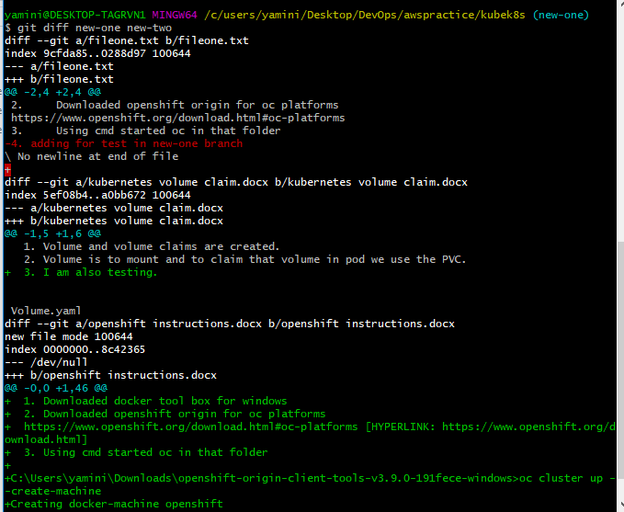

1. Diff –git a/fileone.txt b/fileone.txt (its comparing left new-one to right new-two branch)
2. --- a/fileone.txt (a new-one branch)
3. +++ b/fileone.txt (b new-two branch)

For example:

In the a new-one branch ( -4. Adding for test in new-one branch is the new one branch which we compared starting)

We see the line in adding for test in new-one branch:

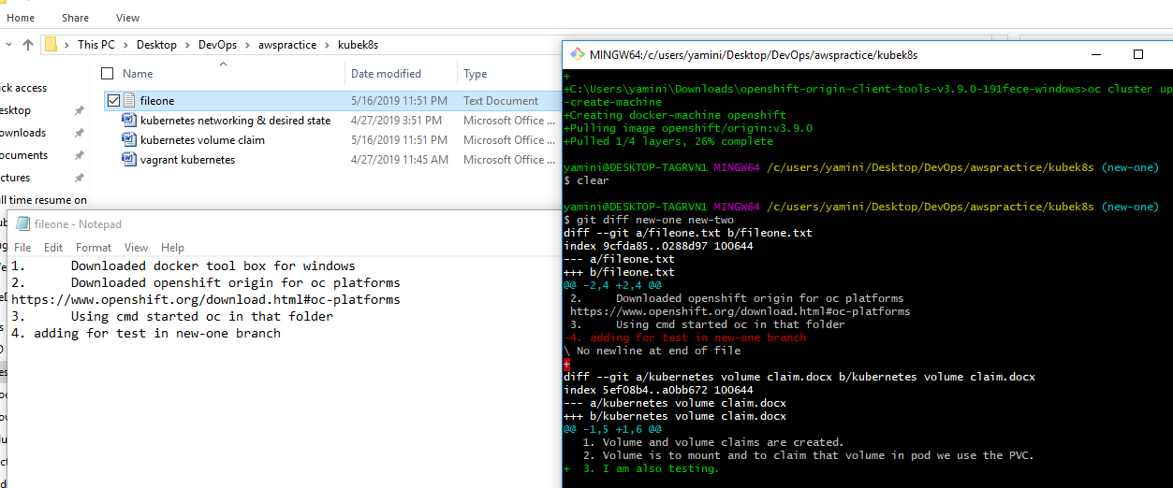

TAGS:

1. Tags create a released version where it is in a detached head state and no longer commits are accepted
2. Git tag (to see the tags)

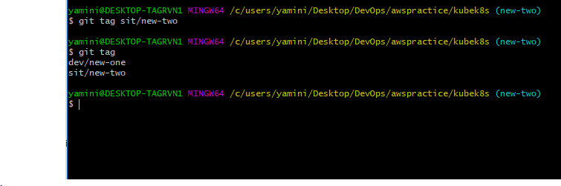

1. After creating tag using git tag sit/new-two
2. We need to push the tag (we need to know remote)

Git remote

Git push –u origin sit/new-two

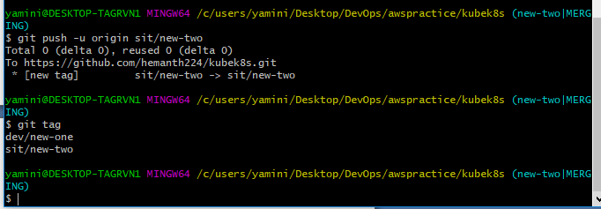

Note: Git tags are checked whether we have latest commit after creation of tags

In repo:

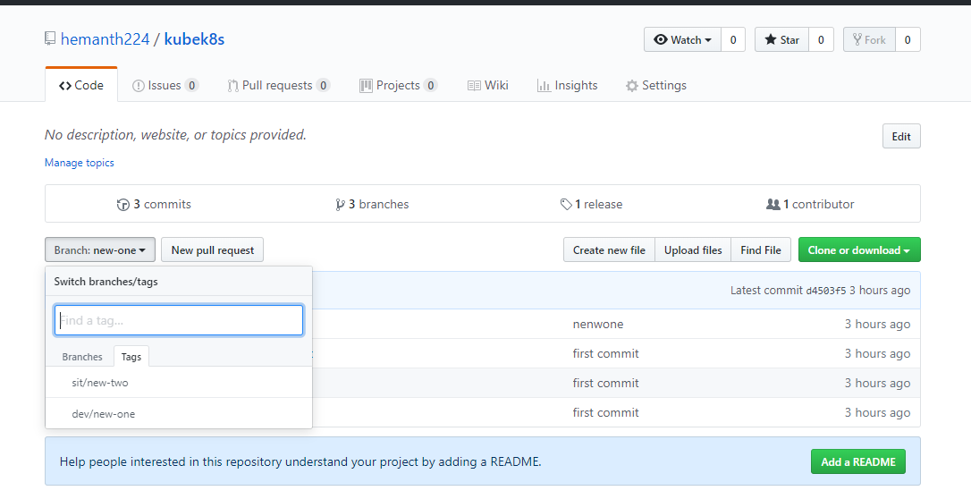

Enterprise and Private git Differences:

1. Enterprise git can have unlimited repos.
2. Private git each repo 7 $ and private can create branches and can have the protected branches which can be treated as master

We can set a default branch:

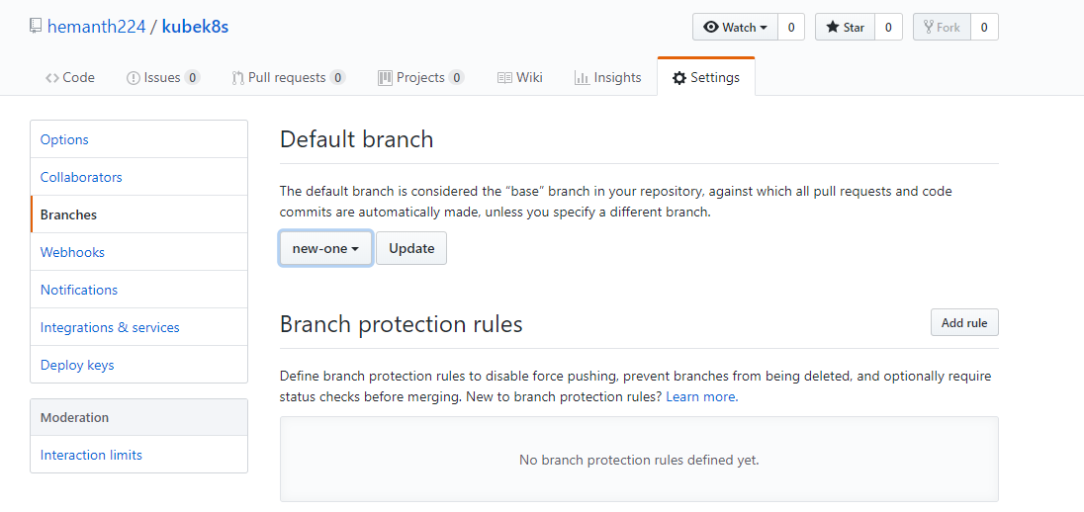

1. In Private git repository we can have protection branches.